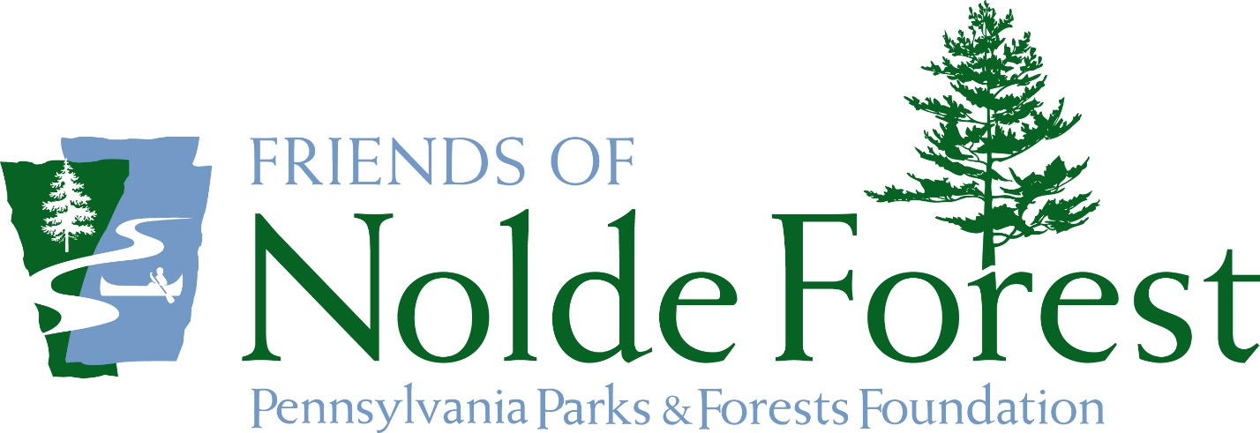

www.FriendsOfNoldeForest.org/join
Help Nolde Forest Environmental Education Center with
your time, talent, and financial support.
Become a Friend of Nolde Forest Today!
Current opportunities include:
- Assist Gardening Committee with the care of native plant gardens
- Help collect, preserve, and interpret the rich history with the History Committee
- Welcome visitors and learn to tell our stories during Mansion Open House events
- Get your exercise, while maintaining and improving our trails with the Trail Crew
- Utilize your planning and communication skills through Special Events Coordination
- Share your love of Nolde Forest with others and help support environmental education and historic preservation with the Fundraising Committee
- And much more!
Monthly Meetings are open to all members on the first Wednesday of the month.
The Friends of Nolde Forest hosts an Mansion Open House and Tour on the first Sunday of the month.
---------------------------------------------------------------------------------------------------------------------------
Name______________________________________________________
Address_____________________________________________________
Email_______________________________________________________
Phone______________________________________________________

Membership fee: $10 individual_____ $25 Family _____ Additional contribution_________
Please make checks payable to: PPFF (PA Parks & Forest Foundation)
**Include “Friends of Nolde Forest” on memo line.
Mail to: NFEEC Friends, Nolde Forest EEC, 3025 New Holland Road, Reading PA 19607

THE FRIENDS OF NOLDE FOREST
The Friends of Nolde Forest provides both physical and financial support to the educational, recreational, and historical aspects of Nolde Forest Environmental Education Center. We assist with programming, maintenance, and improvements to increase accessibility, enhance visitor experiences, and preserve and protect the natural, cultural, and historical resources for future generations.
The goals of the Friends of Nolde Forest directly aligns with PPFF’s 2020 strategic plan. Most notably, our goal of investing in transformative projects and opportunities to enhance and conserve our public lands, with a specific focus on improving the health of our community and environment. The Friends of Nolde Forest have identified opportunities to help make Nolde Forest more welcoming, safe, and accessible for visitors by:
- Installing pathway lighting for improved visibility during evening programming
- Replacing the boardwalk at Painted Turtle Pond Teaching Station
- Fundraising to construct a teaching pavilion for increased outdoor education opportunities
- Expanding ADA accessibility over existing trails to allow visitors to experience nature along Punches Run and deeper into the forest
- Preserving the stories of the land through historic preservation of existing structures
NOLDE FOREST
Nolde Forest Environmental Education Center encompasses more than 725 acres of deciduous woodlands and coniferous plantations open to the public daily from sunrise to sunset. A network of more than ten miles of trails makes the EE Center’s streams, ponds, and diverse habitats accessible to both students and visitors. In addition, Nolde Forest education staff visits classrooms, creates virtual content, welcomes school students, and hosts community programs throughout the year. Nolde Forest EE Center is not only one of Pennsylvania’s 121 state parks, but it also has the distinction of being Pennsylvania’s first Environmental Education Center operated by the Department of Conservation and Natural Resources.

THE PENNSYLVANIA PARKS AND FORESTS FOUNDATION
Pennsylvania Parks and Forests Foundation (PPFF) began in 1999 as a statewide nonprofit organization to provide a voice for the Commonwealth of Pennsylvania’s state park and forest lands. With PPFF, individuals can donate money to specific state parks and forests, become active and involved volunteers in the park and forest system, and participate in fun and educational opportunities. PPFF’s status as a registered 501 (c)3 non-profit charity allows chapter friends groups, such as Friends of Nolde Forest to operate on our public lands for the benefit of everyone.

PARTNERSHIPS
The Friends of Nolde Forest partners with a wide variety of local organizations to help improve the physical and mental well-being of our community. Our relationships with organizations such as the Angelica Creek Watershed Association, Mengel Natural History Society, Mifflin Community Library, Baird Ornithological Club, Barrio Alegria, Art Plus Gallery, Pagoda Pacers, Pheasants Forever, and the Master Watershed Stewards helps promote and encourage diversity, equity, and inclusion within Berks County and beyond.

